# How to use Cisco Academy

Firstly, check your University of Bedfordshire email for the course link sent to you.

If you cannot find it:

Visit

<http://Cisco.netacad.com>

Login with your University of Bedfordshire email address (the one that is your [firstname.surname@study.beds.ac.uk](mailto:firstname.surname@study.beds.ac.uk))

If you cannot log in, then you need to resend the activation link to your beds email address here:

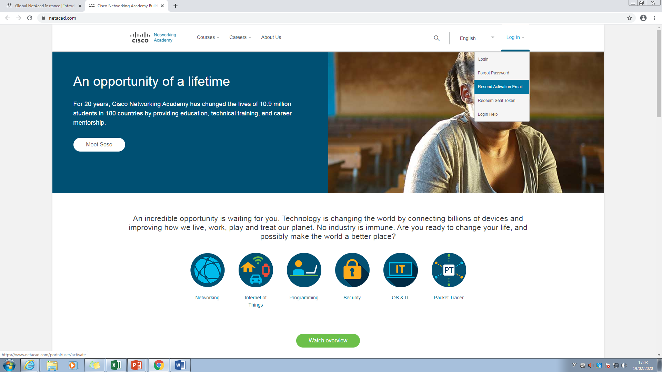

Then check your email and follow the link.

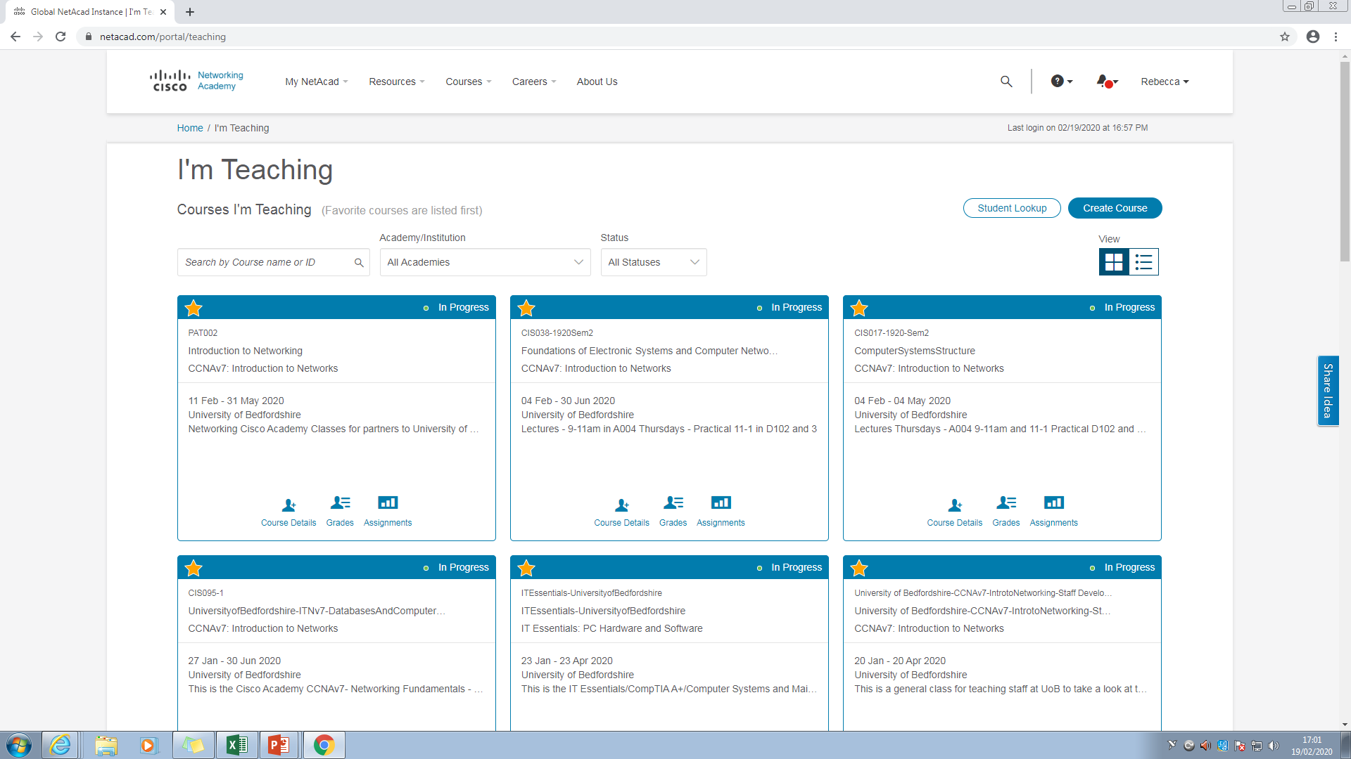Once you are logged into the Academy you should see the following class under I’m learning:

Click this class and launch the course.

Click Modules to access most of the course content

Click here to access the course content (the short powerpoint versions of this curriculum are on Breo)

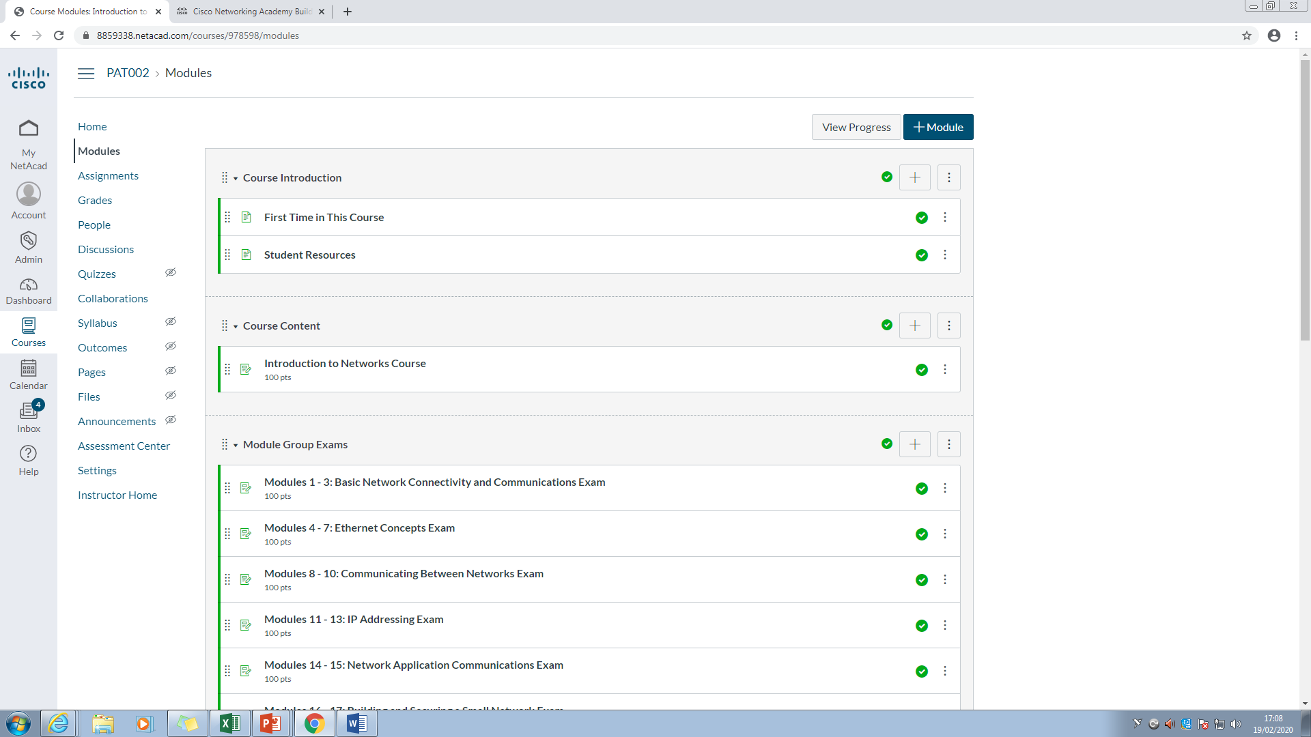

Click here to access the module practise exams – you should be attempting to complete at least 2 modules per week (and one of these practise exams every couple of weeks) to stay on track. NOTE: you do not _have_ to take these to pass the course – you just need the course feedback and the final exam but these are good practise for question that come up on the final.

# Seeing your wrong answers from the gradebook

Once you have competed an exam you can see the correct answers by following these steps.

Go back into modules and click on the exam again – where you see the percentage % grade – click on this – it will display the questions you got wrong (with the correct answer)